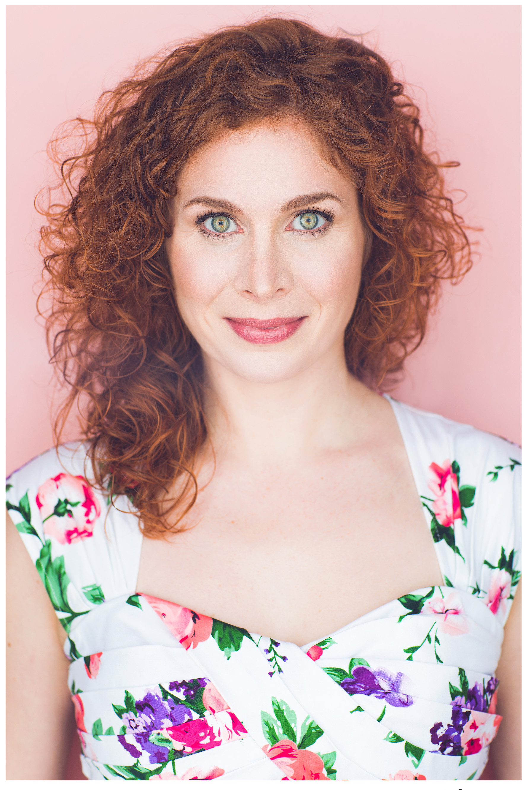
Dana Aber
a fierce & funny femme fatale
the glamour girl next door

AEA
Legit Soprano to 6Eflat, Rock Riff/Belt to A5 Stats: 5’5” Size 6-8
DanaAber@gmail.com Hair: Red Eyes: Green
917-557-0397 : DanaAber over 18K views

International/Tour
Albee’s The Play About the Baby Girl Edinburgh Fringe Festival
Star Wars Trilogy in 30 Mins Boba Fett Edinburgh Fringe Festival
If This Hat Could Talk Eleanor Roosevelt National Tour, dir. George Faison
Shout! The Mod Musical Orange Girl NCL Productions, dir. Kim Jordan
#YesAllWomen, Raise Your Voice Emcee / creator The Tank NYC / ACT Black Box, San Francisco
Circurious Lead singer & magic asst Circus tour, Cirquetacular Entertainment
Genesis Magic Spectacular / Balls! Lead Singer / Star DFP Theatre, Thailand

Solo Performances
Baggage at the Door one-person musical The Girl ONE Festival, Teatro LATEA *Official Fest selection
The Quarantined Waitress Waitress / Patrons Webseries, self-filmed/produced
She Wore Mascara to the Mountain City Mouse Elsewhere Studio Residency multimedia performance
FINAL BLOW – upcoming premiere The Bride Winterfest NYC

Theatre NYC
Tumbleweed – upcoming Off-Bway Rebecca 14 Street YMCA
10 Days in a Madhouse upcoming Off-Bway Nurse Grady Player’s Theatre
The Bet a new 2-person musical Diana Midtown Intl Theatre Fest *Best Actress award
Perfect 36 by Mel Marvin Diana New 42nd Street Studios
Tartuffe Mme. Pernelle Studio @ Theatre Row
Cotton Candy and Cocaine Ashley Ars Nova / Drama League
Baggage at the Door one-person musical The Girl ONE Festival, Teatro LATEA *Official Fest selection
Pirate Bess Bess Classical Theatre of Harlem/ FDCAC
Squiggy and the Goldfish Mom Workshop Theatre

Regional Theatre
Baggage at the Door – upcoming premiere The Girl Zeider’s American Dream Theatre, VA
Soul on Fire Diana the Demon Kennedy Center, D.C.
Ragtime Mother Mercury Theatre Company, OH
My Fair Lady Mrs. Eynsford-Hill Actors Theatre of Louisville ; Cleveland Play House
A Streetcar Named Desire Blanche, u/s perf. Syracuse Stage, NY
Touch Julia Barrington Stage Co. / Drama League Fellow
All Shook Up Miss Sandra Mercury Theatre Company, OH
Titanic Mrs. Widener Virginia Musical Theatre, VA
Ruthless! the Musical Judy/Ginger Mercury Theatre Company, OH
Footloose Ariel Empire Stage, NY
You’re a Good Man, Charlie Brown Lucy Bowling Green Firelands Stage, OH

TRAINING / ACCOLADES B.F.A. Musical Theatre, Syracuse University cum laude
Elsewhere Artist Residency, CO 2019
Best Actress in a Musical, Midtown Intl Theatre Fest 2017
Dorothy Hass 2002-2003 Acting Scholarship, Walnut Street Theatre, NATS Musical Theatre 1st Place Regional
9 years of workshopping new musicals for NYU GMTWP theses, presentations, and demos: dir. Mel Marvin

SKILLS
Producer: Big Thunder Productions, NYC: Emcee/Hosting, strong film/video editing, marketing skills, copywriting
Voice: Studiowork, Voice Overs, classically trained first soprano, pop, folk, very strong Sight-Singer, great with harmonies
Accents: Cockney, Scottish, Czech, Israeli, MidWest Ohioan/Minnesotan, stereotypical-man, basic millennial
Other: Excellent physical mimicry, improv, flute & piano training, disproportionate physical strength: clapping pushups etc

